“Trust in the LORD and do good;
Dwell in the land and cultivate faithfulness.
Delight yourself in the LORD;
And He will give you the desires of your heart.”
-- Psalm 37:3-4
- Please show all your work! No partial credit will be given for incorrect answers with no work shown. Please draw a box around your final answer.
- Calculators are permitted, but no notes, text, laptops, PDAs, or electronic dictionaries. Cell phones should be muted and left in your pocket or bag.
- Table 3 is attached to the back. You may detach it for your reference.
Total marks: 70

- Mark each of the following variables as categorical (G), ordinal (O), discrete (D), or continuous (C). [5]
  - Blood glucose level (mg/dLi) Continuous
  - Location of injury: e.g., knee, lower back, shoulder, chest, etc. Categorical
  - Number of nurses in a hospital Discrete
  - Hospital wait time, coded as 0-30mins, 30-60mins, 1-2hrs, or ≥2hrs Ordinal
  - Whether a woman is pregnant or not Categorical
- The diagram below is a normal probability plot of log-transformed values of beryllium lymphocyte proliferation (a screening test for chronic beryllium disease). (The scale is along the left edge.) How does the distribution differ from a normal distribution? Sketch the distribution, highlighting where it is non-normal. [4]
E L Frome, M H Smith, L G Littlefield, R L Neubert, and S P Colyer, “Statistical Methods for the Blood Beryllium Lymphocyte Proliferation Test”, Environ Health Perspect. 1996 October; 104(Suppl 5): 957–968.
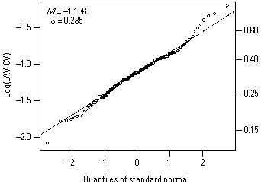
Values at the low end are lower than normal; values at high end are higher than normal, so the distribution has slightly thicker tails than normal
- In a population of nursing students, would you expect marital status (married or not) and eye colour (e.g., brown vs. other) to be independent? Why or why not? [3]
Yes, independent – prob. of being married does not depend on eye colour.
- The list below shows the average life expectancy for nine nations.
Construct a relative frequency histogram, classifying the data by bins of 10 years. [4]
China: 73 | Canada: 81 | Mexico: 76
Haiti: 61 | Peru: 71 | Afghanistan: 45
Singapore: 82 | Tanzania: 52 | Cambodia: 62
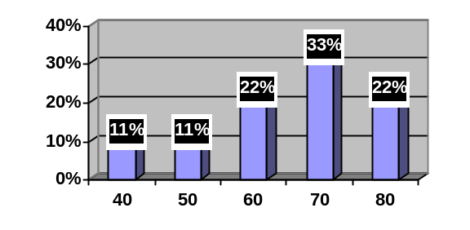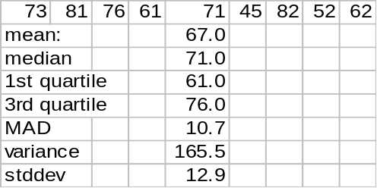
  - Calculate the mean of this sample. Please show your work. [2]
67
  - Calculate the standard deviation of national life expectancy in the sample. Please show your work. [5]
~12.86
  - Draw a boxplot for the data. Show all your work. [4]
min=45, Q1=56.5, med=71, Q3=78.5, max=82
  - Does the distribution appear normal? Why or why not? [2]
No, skewed to the left
  - If the sample size were increased to 90, would the distribution of national life expectancy appear more normal? Why or why not? [3]
No – this is the distrib of the population (not SDSM), which we don’t know.
- A particular FDG-PET (fludeoxyglucose positron-emission tomography) screening test for non-Hodgkin’s lymphoma has a 11% false-positive rate (89% specificity) and 82% sensitivity (i.e., 82% of lymphomas are caught by the screening process).
  - Suppose the screening test is applied to 150 patients, of which 35 have non-Hodgkin’s lymphoma. Draw an event tree for the outcomes of the test, and label the tree with probabilities for each branch of the tree. [5]
(has lymphoma: 23.33%) (no lymphoma: 76.67%)
(test +: 82%) (test -: 18%) (test +: 11%) (test -: 89%)
(has, +: 19.13%) (has, -: 4.2%) (no, +: 8.43%) (no, -: 68.23%)
  - On average, how many people in this group will test positive for non-Hodgkin’s lymphoma? [3]
19.13% + 8.43% = 27.57%
27.57% (150) = 41.35 people
  - If a patient tests positive using this test, what is the probability that the patient really has non-Hodgkin’s lymphoma? [3]
28.7 / 41.35 ≈ 69.41%
- The age of a population of nurses is assumed to be normally distributed with an average age of 38.0 years and standard deviation of 6.4 years.
  - What is the 60th percentile age? [2]
(T3) z ≈ 0.25
38 + 0.25(6.4) = 39.6 years
  - What fraction of nurses in this population are in their thirties (30-39 years old)? [3]
y = 30 ⇒ z = (30-38)/6.4 = -1.25 ⇒ (T3) area = 0.1056
y = 39 ⇒ z = (39-38)/6.4 ≈ 0.16 ⇒ (T3) area = 0.5636 (or y = 40 ⇒ area = 0.6217)
0.5636 – 0.1056 = 45.80% (or 51.61%)
  - If we select four nurses from this population, what is the probability that their average age is within ±2 years of the mean? [3]
z = ±2/(6.4/sqrt(4)) = ±2/3.2 = ±0.625 ≈ ±0.63
(T3) area = 0.7357 – 0.2643 = 47.14%
(or if use z = ±0.62, 46.48%)
  - If we did not know the mean age, how many nurses would we need to query to estimate the mean age to within ±2 years, with 95% confidence? [4]
95% conf ⇒ (T3) z = ±1.96 ⇒ 1.96 = 2/(6.4/sqrt(n)) ⇒ n = (1.96(6.4)/2)² ≈ 40
- Consider a sample space of patients in a community health program. Let A be all patients in the program who have Alzheimer’s disease, and B be all with in-home care. Translate each of the following statements into probability notation using A and B, and draw a Venn diagram in the box provided, shading in the region described. (If it’s a conditional probability, write “not applicable” in the Venn diagram.)
  - 3 out of every 20 patients in this program have Alzheimer’s disease. [2]
P(A) = 0.15
A
  - 10% of patients in this program are Alzheimer’s patients with in-home care. [2]
P(A ∩ B) = 0.10
B
  - 25% of patients in this program either have Alzheimer’s or have in-home care. [2]
P(A u B) = 0.25
B
  - What fraction of patients in this program do not have in-home care? [3]
P(B) = P(A u B) – P(A) + P(A ∩ B)
= 0.25 – 0.15 + 0.10 = 0.20
so P(B^{c}) = 1 – 0.20 = 0.80 = 80%
  - What fraction of Alzheimer’s patients in this program have in-home care? [3]
P(B|A) = P(A ∩ B) / P(A)
= 0.10 / 0.15 ≈ 0.67 = 67%
  - In this program, is having Alzheimer’s independent of having in-home care? Why or why not? [3]
No: 20% = P(B) ≠ P(B|A) = 67%
Alzheimer’s patients are more likely to have in-home care.

